Simple Machines

A simple machine is a simple tool that makes work easier. Compound machines have multiple simple machines working together to make work easier.

In science, work is defined as force acting on an object to move it across a distance. Pushing, pulling and lifting are all common forms of work.

There are 6 simple machines.

Inclined Plane

An inclined plane is a surface that is set at an angle to the horizontal. It allows objects to be raised with les effort than would be needed to lift it straight up.

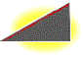Ramps are used in shopping centres and other buildings to allow wheelchairs and prams to be raised with less effort. Although smaller effort needs to be made, a greater distance must be travelled.

Ramps, hills and slides are examples of inclined planes.

Wedge

A wedge is made from two inclined planes with their horizontal edges together. The sloped sides of the inclined planes meet to form a sharp edge. This edge can be used to split things apart by reducing the force needed to cut through the object.
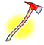
Knives, axes and nails are examples of wedges.

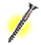
Screw

Take an inclined plane and wrap it around a cylinder. Its sharp edge becomes another simple tool: the screw. It is a curved ramp. However, instead of an object being pushed up the ramp, the ramp is pushed down into the object. Car jacks use a large screw to lift huge loads with little effort.
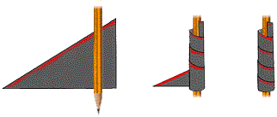
Jar lids, jacks, clamps and spiral staircases are examples of screws.

Lever

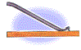Any tool that prises something loose is a lever. A lever is a board or bar that rests on a turning point. This turning point is called the fulcrum. An object the lever moves is called the load. The closer the load is to the fulcrum, the easier it is to move.
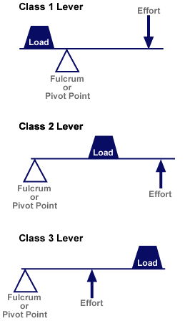First-class Levers
In a first class lever, the fulcrum lies between the effort and the load. First-class levers are force multipliers. They allow you to move a large load with a small force.

Some first-class levers are crowbars and seesaws.

Second-class Levers
Second-class levers are also force multipliers; however, the load is between the fulcrum and the effort.

Some second-class levers are wheelbarrows and nutcrackers.

Third-class Levers
Levers with the effort between the fulcrum and the load are called third-class levers. This type of lever is not a force multiplier, they are a speed multiplier.

Some third-class levers are cricket bats, brooms and tennis racquets.

Wheel and Axle

The wheel and axle can move objects across distances. The wheel, the turns the axle, a cylindrical post attached to the centre of the wheel, which causes movement.

A wheel and axle is a force multiplier. You apply a small effort to the wheel to move a large load with the axle.

They can also be used to make things move faster. A ceiling fan is a wheel and axle. A large force is applied to the axle. Each time the axle turns the fan blades move a much greater distance in the same amount of time.

Door knobs, gears and clocks and fans are examples of wheel and axles.

Pulleys

Instead of an axle, the wheel could also rotate a rope or cord. In a pulley, a cord wraps around a wheel. As the wheel rotates, the cord moves. If a hook is attached to the cord, the wheel’s rotation can be used to raise or lower objects.

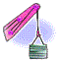A single, fixed pulley can be used to make lifting a load easier. It does not decrease the amount of force needed to lift the load, but changes the direction of the effort. Using more than one pulley will decrease the force needed to lift the load.

Flag poles, blinds and cranes are examples of pulleys.
Practical Activities
Inclined Planes

Aim: To examine the relationship between forces and distance on inclined planes.

Equipment: Small stack of textbooks or a dictionary
Wooden board
Set of slotted masses
5N spring balance

Procedure:
- Place the textbooks in a pile.
- Place the slotted masses next to the pile of books and use the spring balance to slowly lift the mass so that its base is level with the top of the pile.
- Record the force measured by the spring balance.
- Lean the ramp against the pile of books to make a long, gentle slope.
- Place the slotted masses at the bottom of the ramp and use the spring balance to slowly pull it until its far end reaches the top of the pile.
- Record the force measured on the spring balance.
- Turn the wooden board around so it makes a short, steep ramp.
- Place the slotted masses at the bottom of the ramp and use the spring balance to slowly pull it until its far end reaches the top of the pile.
- Record the force measured on the spring balance.
- Change the height of the stack of books and repeat the process with two different heights.

Height of books (cm) | Length of gentle slope (cm) | Length of steep slope (cm) | Force used to lift straight up (N) | Force used for gentle slope (N) | Force used for steep slope (N)
Results:

Questions:
- Does it take more force to lift the mass straight up or along the ramp?

- In which case does the mass have to move further?

- Which method of raising the mass is better? Why?

- Look at your measurements of force and distance. Can you see a pattern?

Wedges

Aim: To observe the action of different wedges in separating wooden blocks.

Equipment: 2 blocks of wood
2 elastic bands
2 wooden wedges, one blunt and one sharp

Procedure:
- Use the elastic bands to hold the two blocks of wood together.
- Try to pull the two blocks of wood apart with your fingers.
- Now, use the blunt wedge to separate the two blocks.
- Now, try using the sharp wedge to separate the blocks.

Questions:
- Could you separate the blocks of wood easily with just your fingers?

- Using the blunt wedge, was it easier or harder to separate the blocks than with just your fingers?

- Is it easier or harder to separate the two blocks with the sharp wedge than with just your fingers?

- Which edge made separating the two blocks easiest?

Screws

Aim: To observe the action of a moving inclined plane, the screw.

Equipment: Self-tapping screw
Block of wood
Screwdriver

Procedure:
- Try to push the screw into the wooden block with your hand.
- Now use the screwdriver to fix the screw halfway into the wood by turning it

Questions:
- Were you able to get the screw into the wooden block by just pushing it?

- How does the thread (the inclined plane) on the screw allow you to get the screw in the block?

Wheels and Axles

Aim: To observe the advantages provided by the wheel and axle.

Equipment: Screw embedded in a block of wood
Screw driver

Procedure:
- Try to remove the screw from the block of wood by turning the shaft instead of the handle.
- Remove the screw by using the screwdriver as it is meant to be used, by turning the handle.

Questions:
- Can the screw be removed by turning the shaft of the screwdriver instead of the handle?

- What difference does using the handle of the screwdriver make to the effort needed to turn the screw?

- During one full turn of the screwdriver, which moves further – the outside edge of the handle or the outside edge of the shaft?

- Is a screwdriver a force multiplier or a speed multiplier? Explain your choice.

- ‘A fan is a speed multiplier.’ Explain what this statement means.

Levers

Aim: To examine the relationship between forces and distances in first-class levers.

Equipment: 30 cm wooden ruler
Pencil
Blu-tack
8 x 50g masses

Procedure:
- Use the blu-tack to hold the pencil to the bench.
- Lay the ruler across the pencil so that it balances in the middle (15 cm).
- Place three masses 12cm from the fulcrum (on the 3cm mark). This is the load. Look at the picture below if you are not sure.
- One at a time place masses on the other end of the ruler until the load is lifted. This is the effort. Record the number masses needed to lift the load.
- Move the load 4cm closer to the fulcrum and repeat step 4.
- Move the load another 4 cm closer to the fulcrum and repeat step 4.
- Record your results in the table.
Load (12 cm from fulcrum)
- 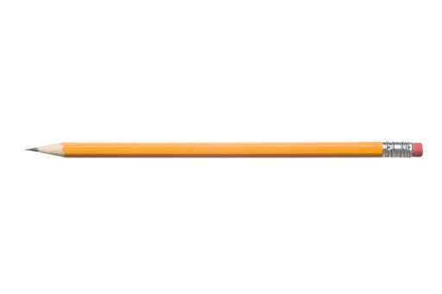Repeat the process for four masses.
Effort
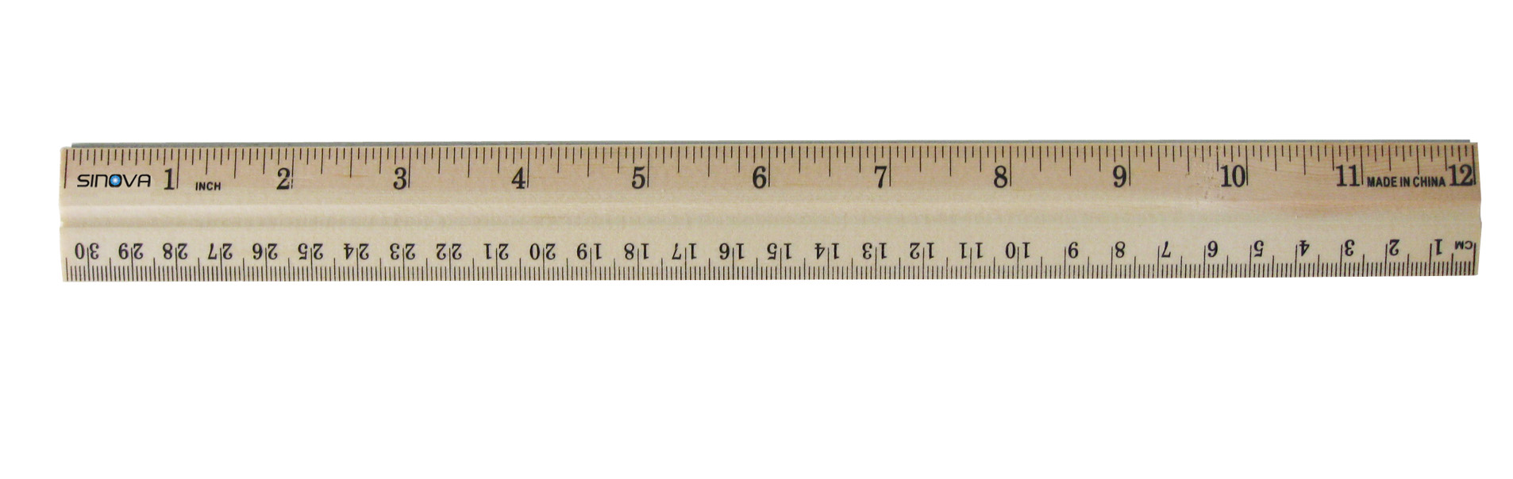

Fulcrum
Results:
Load (number of masses) | Distance from Fulcrum (cm) | Effort (number of masses)
3 | 12 cm
3 | 8 cm
3 | 4 cm
4 | 12 cm
4 | 8 cm
4 | 4 cm

Questions:
- Describe any pattern you can see in the data you have collected.

- Why is this type of lever called a force multiplier?

- Would there be any advantage to using this type of lever to raise a light load with a large effort? Explain your answer.

Pulleys

Aim: To examine the relationships between forces and distances in pulley systems.

Equipment: 2 triple pulleys
1 metre length of string
Set of slotted masses
5 N spring balance
Retort stand
Boss head and clamp
2 bricks
Procedure:
- Set up the retort stand, boss head and clamp so that the boss had and clamp is at the very top.
- Extend the clamp so that it is at the very end.
- Place the retort stand on the edge of the bench and put the bricks on the base to weigh it down.
- Attach one pulley to the slotted masses and use the spring balance to find its weight, in newtons. This weight is the load that is to be lifted.
- Attach the piece of string to the top of the pulley attached to the masses. Thread the string through the lowest pulley at the top. Look at diagram one to help you.
- Attach the spring balance to the end of the string and pull on the balance slowly so that the load is lifted 10 cm upwards.
- Record the force on the spring balance. This is the effort.
- Also record how far you had to pull the string to lift the load.
- Now arrange the system with 2, 3 and 4 pulleys and record the effort needed to lift the load 10 cm. Use the diagrams to help you thread the systems.

One pulley Two pulleys

Three pulleys Four pulleys

Results:

Pulley Arrangement | Load (N) | Load Distance (cm) | Effort (N) | Effort Distance (cm)
Single pulley |  | 10 cm
Two pulleys |  | 10 cm
Three pulleys |  | 10 cm
Four pulleys |  | 10 cm

Questions:
- The effort needed to lift the load using a single pulley is the same as lifting it straight up. Explain why a single pulley is still useful.

- Does the effort needed to lift the load increase or decrease when you add more pulleys?

- Does the distance you need to pull the string increase or decrease when you add more pulleys?

- Predict the effort that would be needed to lift the load with five pulleys. Predict how far you will need to pull the string.

Simple Machines
Workbook

Name: ________________________

